DRAFT Report to AfroPHC Annual General Meeting 19th May 2022
UPDATED 8th May 2022

- AfroPHC Executive Board: The nine Executive Board (EB) members elected were in order of count: Shabir Moosa, Radha Karnad, Innocent Besigye, Joseph Ana, Bongi Sibanda, Francoise Nwabufo, Abdellah Almoghirah, Cynthia Chaibva, Godwin Aja. At the first meeting Shabir Moosa resigned to serve as Executive Coordinator. Marie-Claire Wangari replaced him as next on the list. The EB then coopted the next two people on the list Lizemari Hugo and Tolu Osigbesan. Lizemari Hugo, as representative of AfriPEN, recused herself and Champion Nyoni of AfriPEN replaced her. Bongi Sibanda later resigned due to work conflicts but has not been replaced. As per Articles of Association there must be a change of at least three EB members every year in the first three years to create a cycle of three elections at the AGM. The EB resolved to manage the vacancies by least attendance of meetings. According to a review, the two EB members selected to vacate were Radha Karnad and Godwin Aja. See details of all EB members here. The EB met monthly except for December 2021-January 2022. All minutes are provided.

- Executive Coordination Team (ECT): A small group of AfroPHC activists have been set up as the AfroPHC Executive Coordination Team (ECT) to groom leaders and to voluntarily support the Executive Coordinator (EC) with organisational tasks. They have met several times since January 2022 and have now settled into a monthly meeting to develop them in various skills e.g. managing a website, using social media, graphic skills using free/cheap online software, managing minutes/notices, managing zoom etc. ECT Members: Mercy Wanjala (Lead Policy Workshops). Elie Badjo (Lead CPD), Jamie Colloty (Lead Clinical Group), Senkyire Kumi (Lead Research), Abeer Kamil, Tijani Oseni, Daniel Otobo, Eleleta Surafal, Marie-Claire Wangari, Zainab Elyas, Akan Obot. Those not attending at all have been removed from end March. ECT minutes are shared with the EB monthly. The ECT presents on their portfolios at EB/AB meetings to learn. Amendments to the Articles of Association have been proposed to allow this development.

- Advisory Board: The EB put the Advisory Board (AB) together from Supporting Organisations and other key persons identified. The full list is on the website. The first AB Meeting held 5th November was very successful with many AB members attending. Matters arising have been addressed: The EC has written to all Supporting Organisations/AB members to strengthen the partnership, link us to other potential Supporting Organisations, speaking at the Conference, request for cases of multidisciplinary training in Africa and explore collaborative papers. Only HIFA has responded to date. The next meeting was held 6th May 2022 in preparation for the AGM. Minutes from 5th November 2021 and 6th May 2022 are provided.

- Stakeholder Engagement

  - Supporting Organisations: After election the Executive Board (EB) actively sought to establish Supporting Organisations. 61 organisations have been identified (some recently), 57 Invited, 46 Responded: 31 Yes, 13 Discussing, 11 No response, 2 Not interested. All Supporting Organizations are up on the website front page. New prospects being explored are: International CHC Movement, East, Central Southern Africa College of Nursing, West African College of Nursing, Consortium of New Sub-Sahara African Medical Schools, SAFRI, Association of Schools of Social Work in Africa (ASSWA). However, contact details are required. All have been emailed to expand the partnership after recommendation by the first Advisory Board Meeting. See details of all Supporting Organisations here.

  - WHO Civil Society Commission: The AfroPHC EC has been involved closely with a civil society group from CSEM in the development of a Civil Society Commission for WHO, a way to engage civil society more actively into WHO processes. There have been several engagements with WHO, including the DG, with plans to open membership applications in January 2022 however progress has been slow. It is yet to be announced and the civil society group is pursuing this actively.

  - WHO NSA Status: WHO Geneva and WHO AFRO were approached for NSA status after a very productive engagement with the PHC Directorate of WHO Geneva. WHO Geneva replied that NSA status should be explored with WHO AFRO as AfroPHC is a regional organization. Follow up is underway in WHO AFRO with the support of WONCA and WHO.

  - AOSIS Partnership: AfroPHC approached AOSIS, custodian of the African Journal of PHC and Family Medicine, for them to consider it being the Official Journal of AfroPHC in addition to WONCA Africa. AfroPHC EC is in discussion with WONCA Africa on their agreement.

- Chapter Development: The Executive Board has been very keen to develop AfroPHC Chapters at a country level. After discussions a manageable plan to set up AfroPHC Chapters across Africa was planned for the 3rd Friday of every month so that all EB members can be present and chair them. A Chapter Meeting for West Africa was held 18th February 2022 with 62 participants from across Africa. A Chapter Meeting for East Africa was held 18th March 2022 with 131 participants from across Africa. Very useful discussions were held, and small teams were formed and linked up in WhatsApp groups. The Southern Africa Chapter Meeting (and others) have been postponed by a month. The SA Chapter was initiated 8th April with a small group and there is a plan to educate widely on NHI/UHC and PHC plans in SA. A webinar will be held 13th May with Dr Kara Hanson on Lancet Global Health Commission on financing PHC for UHC. The overall plan is to build AfroPHC at country level by identifying key organisations and focal persons in PHC and then to build a network of members in each country. The objective would be to mobilise all groups to contextualise unique regional/national issues, build link to governments starting with WHO country representatives to help engage national and local government structures and build AfroPHC as a forum to advocate for PHC. In building AfroPHC membership it was felt important to recruit amongst student-professional associations and local NGOs, develop an academic network around the training initiatives of AfroPHC, and use world health days - social media to recruit-mobilise. EB members are expected to lead these initiatives.

- AfroPHC Youth Hub: Marie-Claire Wangari was tasked to set up an AfroPHC Youth Hub. This was established in October 2021 with AHEEs, Youth4UHC, FAMSA, IFMSA, IPSF-Afro, ANNSI, IADS with a steering committee as of 2nd March 2022. They have set out focus areas as PHC advocacy/policy, universal access to PHC, capacity building and COVID-19. There first event was a side event at the First International Conference on Public Health in Africa (CPHIA) 15th December 2021. See more details here. The Youth Hub presented on their plans and ideas on structure at the Advisory Board meeting of 5th May 2022. It was decided that the interim team continue and that a more robust approach to integrate youth leaders into current AfroPHC leadership structures be explored byetween the Youth Hub and the EC. The EB is fully supportive of efforts.

- Policy Workshops: AfroPHC has continued the tradition of interactive policy workshops started in 2020. There have been a series of monthly workshop in 2021 expanding on the issues of concern: HR management, development of PHC clinicians in Africa, Supporting CHWs and Health Promotion in PHC, PHC funding / payment reforms in Africa, Exploring complexities in PHC/UHC, Educating the team on PHC, Quality-safety for PHC/UHC, Rural PHC in Africa, and Digital Health for PHC/UHC. This continued in 2022 with Models of Team Practice, Rehabilitation in PHC, Value of Pharmacists in PHC and a plan for others including Oral Health, Labs/POCT, Mental Health, One Health, Women, Workers Health and Health Equity. Planning for the next policy workshop: “Point of Care Testing in African PHC” on 21st June, 2022 is underway. Attendance has been between 50 and 100 each time with strong participation and diversity from not only health related fields but non- health related fields such as economics, with good feedback. Much of the discussion has been recorded and contributions are being channelled into the draft policy paper. Recordings and presentations are available with more detail here.

- Policy Documents: A Draft Policy Document on "Building PHC Teams for UHC in Africa" 2022-03-24 has been developed after much delay. It integrates the proceedings and discussions of the many policy workshops held. This is being circulated and is core to the AfroPHC Conference 2022. See attached.

- Training: Management: This is a course in Leadership-Management and Health Systems Strengthening in partnership with AMREF. There were 708 students enrolled in 2021 but 110 engaged and only 18 completed, as it was fully online with poor-no support systems. An evaluation end 2021 suggested that more support was required over a longer period. AfroPHC has rolled out the training in 2022 with an orientation, monthly meetings from 8th March (aligned to each module over 10 months) and a Google Group. Teachers are lined up for all modules. There are more than 400 people registered for the course with attendances at 50-100 per session. An evaluation will be done at the end of 2022.

- Training: CPD: Weekly CPD for Johannesburg Health District was supported by AfroPHC until end 2021 with ±50 participants. AfroPHC was included in a WONCA Africa partnership with World Continuing Education Alliance (WCEA) early 2021. The Jhb CPD was taken over by AfroPHC and moved to the WCEA platform from February 2022. It is continuing very successfully with 400-1000 attendees. Slots are filled for most of the year. We have a monthly French session whilst all sessions have English French translation. The CPD webpage has lots of guidance on using the WCEA platform as well as a list of CPD webinars planned for 2022.

- Training: PHC/Family Medicine Clinical Post-Graduate Diploma: The idea is to create a curriculum framework for a 15mth online distance-based clinical up-skilling course for doctors, nurse clinicians and clinical officers to prepare them for PHC/UHC efforts. The focus is on priority conditions (communicable and non-communicable diseases, mental health, geriatric-palliative care, mother-child-adolescent, trauma-violence) as well common clinical practice. Family Medicine/PHC theory and practice as well as practice management feature strongly. Fair progress has been achieved on building a repository of material and developing a course outline. A group has been created to review and improve the curriculum framework by end 2022. This would serve as an advocacy tool as well as an offering to academic institutions to explore delivery of this course. AfroPHC would itself consider this for 2025 if funds can be raised before end 2022 to develop the online delivery learning process and materials. More details here.

- Research Group: AfroPHC has found much interest in research amongst members. It set up research meetings in 2021. There has been some progress in the meetings with overviews of PHC documents, exploration of the platform for research, sharing of proposals and resources. The plan in 2022 is monthly meetings covering the development of a proposal. This is to be allied with a mentorship programme. There are 69 Researchers (whether university student or not) that have joined the programme. In addition, there are 54 Supervisors (With a masters/PhD and liaising with student 1-2 weekly (at least mthly) to complete tasks) and Reviewers (With a masters/PhD and reviewing documents from student / supervisor two monthly x 3). They are being matched and the teaching programme being filled. See details here. The AfroPHC research agenda is moving along with the first meeting on 5th April on “An overview of PHC research” and a second on 5th May on “Developing a research question” to help mentor researchers, inspired by the Afriwon Research Collaborative programme. AfroPHC is also in discussion with Afriwon Research Collaborative (ARC) in support of this mentorship programme. The EC has joined the ARC Advisory Board. Research on Digital Health in Africa conducted with Imperial College London at the November 2021 Policy Workshop on Digital Health is being written up with ECT facilitators / Imperial College London. AfroPHC is a co-applicant in a successful Wellcome Trust funded bid to develop the African Population Cohort Consortium (APCC) over 18 mths. AfroPHC is seen as key in guiding the APCC to link population cohorts to PHC and UHC efforts across Africa. AfroPHC will receive $7500 for this. A collaboration has begun with Dr Anna Dania of Maastricht University to support efforts at building an AfroPHC Practice-Based Research Network (PBRN).

- Communication
- Website https://afrophc.org/

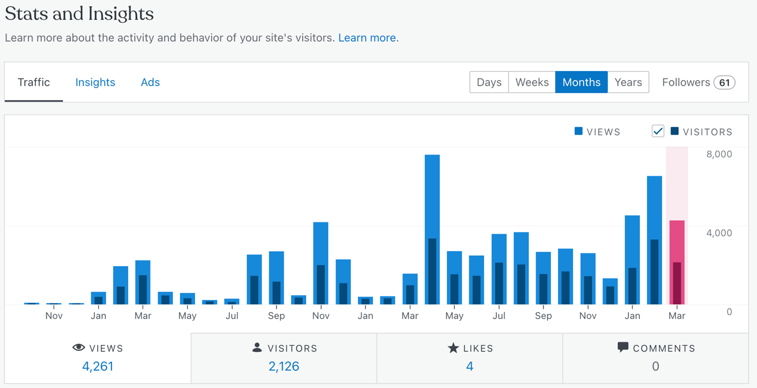
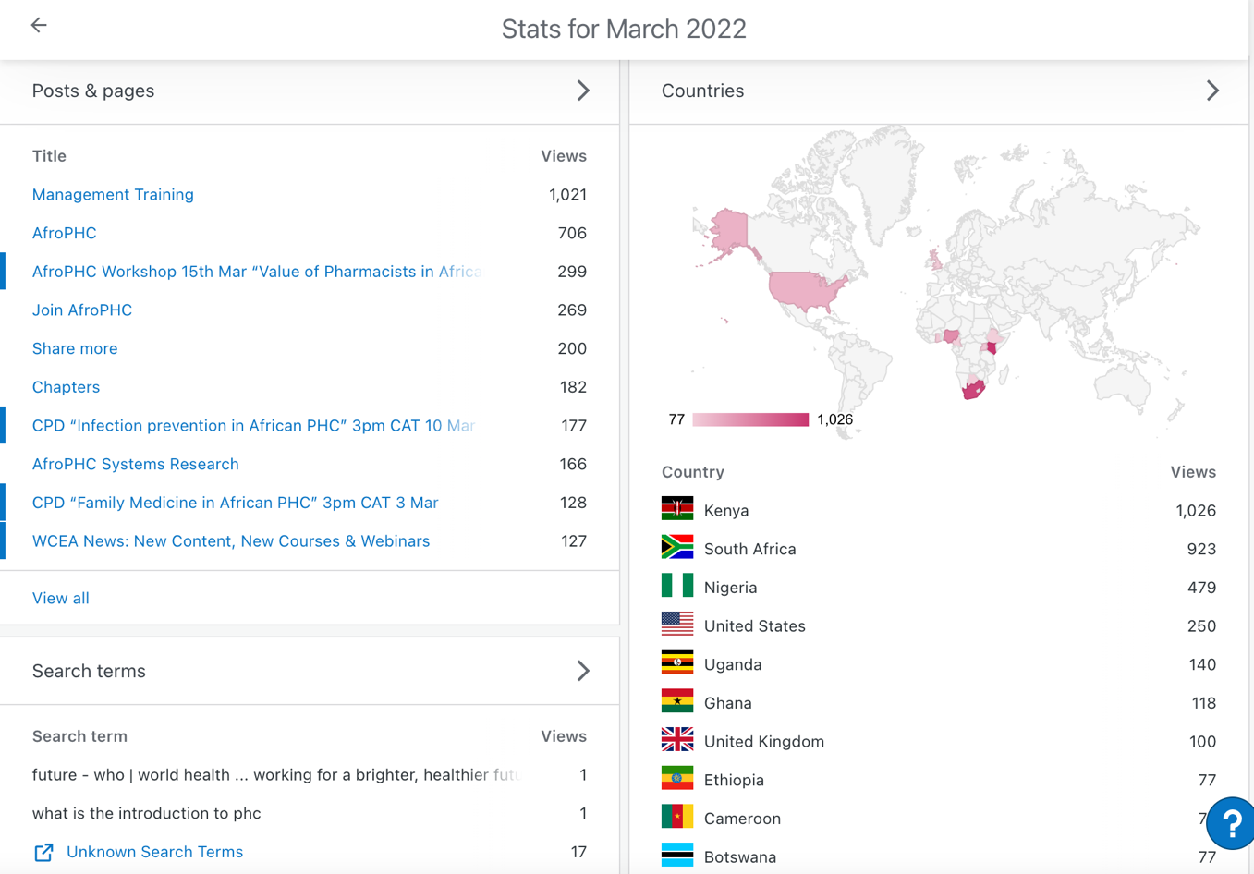

- Social Media cross-posts

https://www.facebook.com/afroPHC
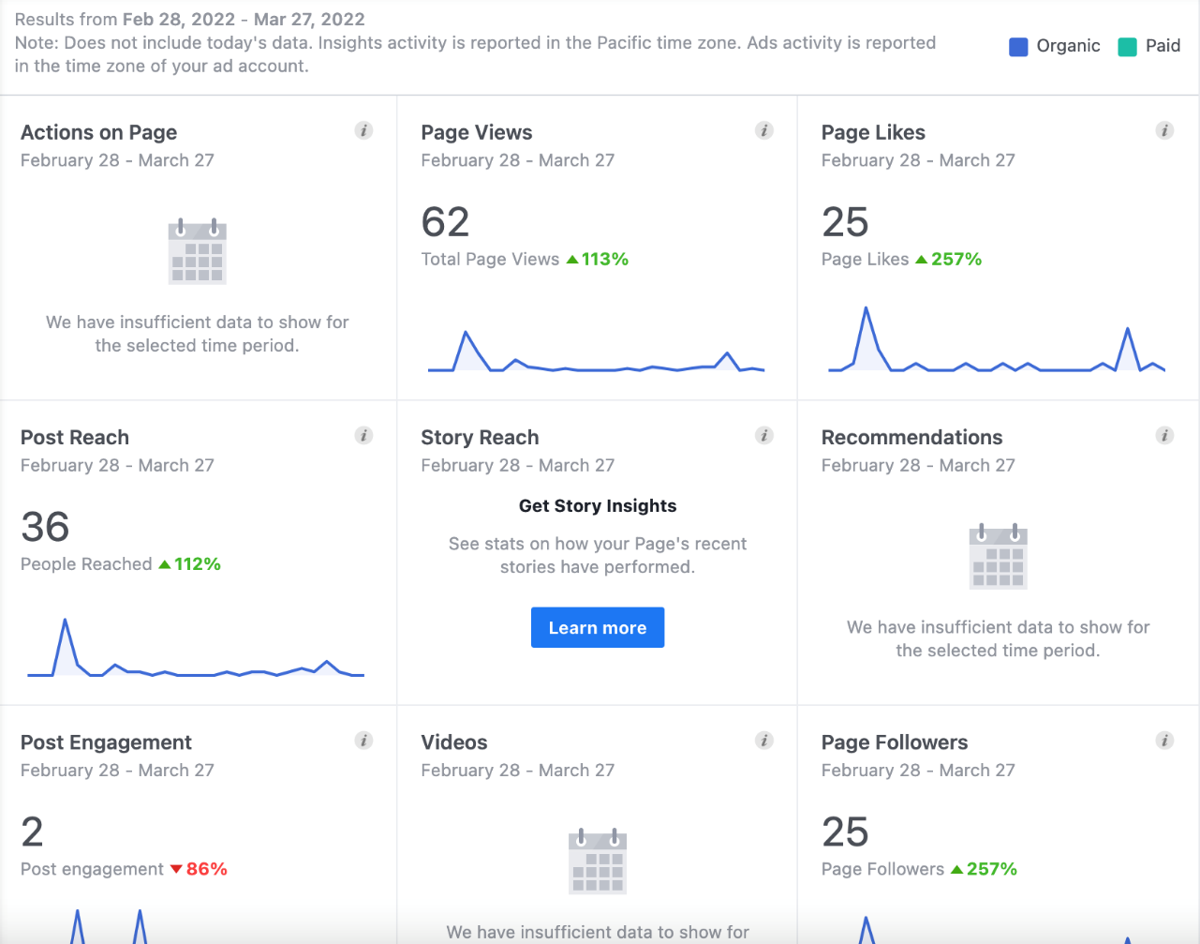

https://twitter.com/AfroPHC
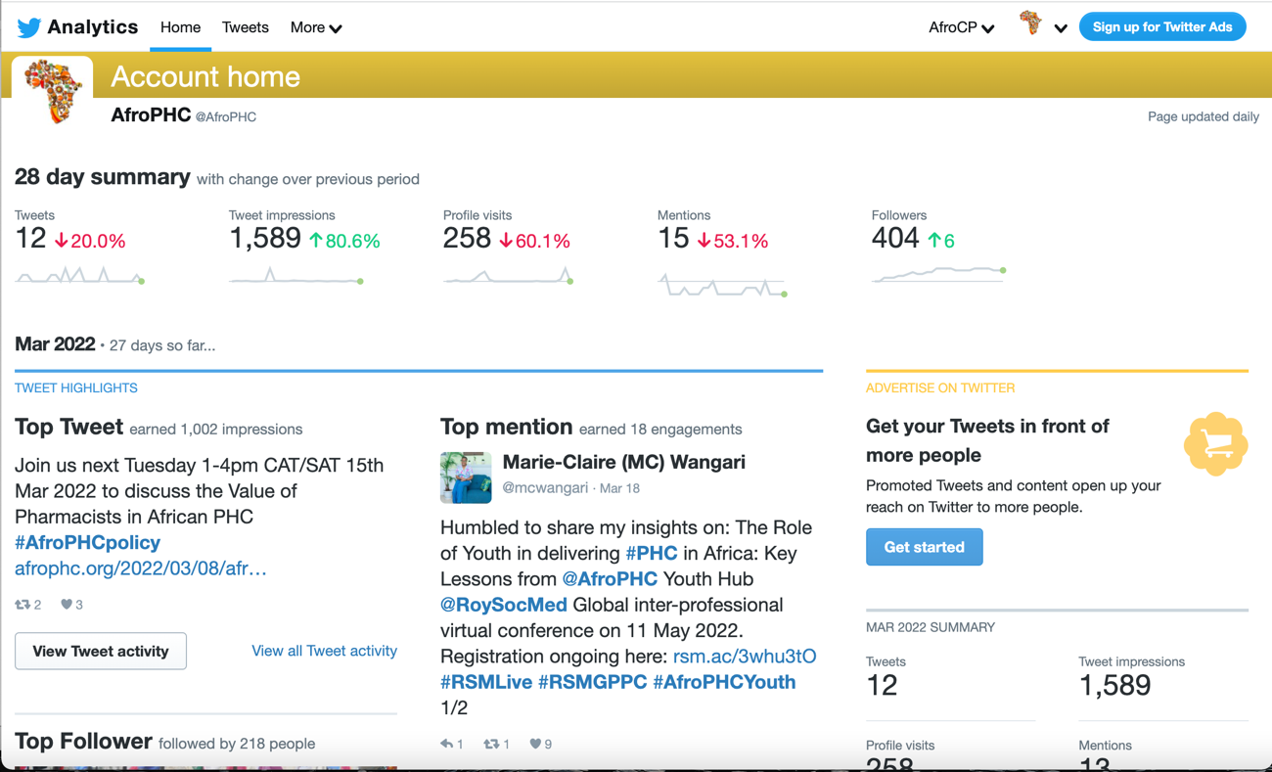

- A regular Newsletter is sent to ±8000 ppl via Engagebay CRM with 35-50% open rate.
- Google Group: Members have grown to 1150 (despite a form challenge) with increasing engagement.
- Press Releases post-Workshop: Nil due to limited time available.
- ECT to improve AfroPHC posts-social media engagement, policy brief and marketing.

- Conference/AGM: Plans for Conference/AGM as advertised. The AGM will require adoption of the report and financial statements, an election of three EB members (calls for nominations in last newsletter), and an election of an audit committee of three members.

- AfroPHC Admin/Organisation
- AfroPHC Membership number has grown to 1232.
- The EB has deliberated on refining membership, by creating 1) a full membership category with access to voting and a fee of $20 for individual and $40 for organisation and 2) an associate membership category that has access to all services but no voting rights and offered free. Full members will get access to a $20 per person (max 2 for organisations) discount at face-to-face conferences in future as an incentive to support participation in the AGM. This makes the membership participating in votes smaller and more select and creates the possibility of raising membership funds of $20-40 per person.
- The EB deliberated over a AfroPHC Strategic/Operational Plan that was fairly finalized by 2021-08-02 and then used to guide the rest of the years activities and to create an AfroPHC Strategic/Operational Plan for 2022 and finalized 2022-02-04. This is attached.
- The Articles of Association have required to be amended to cater to the following issues (changes are in track change in the document attached)
  - Creating a full membership category with access to voting vs an associate membership category that has access to all services but not voting.
  - Expanding the capacity of the EB to contract more responsively than waiting for such decisions annually at an AGM
  - Allowing the Executive Coordination Team to continue and be recognised in the Articles of Association.
  - Amend the rules of the Advisory Board to be more flexible and reflect better practice as experience over the past year.
- Company: This is still AfroPC NPO as registered with the directors: Shabir Moosa, Ayesha Moosa and Zahra Moosa. The EC is still busy with change in directors and name change.
- Budget: Full $940 / Basic $3500 / Min $1840*
AfroPHC Budget | USD
AfroPHC Wordpress* | 400
GoDaddy Domain Renewal* | 80
Zoom Meeting/Webinar (500)* | 1360
Engagebay CRM | 1000
Placeit Subs | 80
Canva Subs* | 120
Telestream | 120
Software/Hardware | 150
Printing | 100
Conferences | 500
Workshop Translators | 1200
Virtual Assistant (Social Media) | 1200
Virtual Assistant (Groups) | 2000
Memberships | 500
Bank Charges* | 150
TOTAL | 8960
- Income / Fundraising
- Funds of R24 528.85 in FNB Account of AfroCP taken over by AfroPHC and used for AfroPHC expenses
- Funds of R120 000 raised from Wits health Consortium and residing there for now with no use yet.
- Potential funding of $7500 for 18mths with APCC success
- Request to WONCA for $3500 x 3-5 years declined
- No progress on company fundraising CPD / WCEA
- Givengain public fundraising set up but no responses
- Expenses to date
- Used WONCA Africa account for most expenses ending Nov 2021
- Paypal A/c Expenses
- French translator Alexandra Oprea for 3hr Policy Workshops $42- 18th May; €42-15th June, $42-27th July, $70-18th Aug, €42-21st Sep, $35-19th Oct 25th Feb-$24
- Digital Inspiration for Google Notifications $39 pa x 2.
- FNB Expenses
- Bank Charges: R80 per month x 10
- EC claim from FNB (R17962.53/1174.58):
- 2021-12-09 WordPress.com Receipt $300 Paid
      - 2022-01-19 Zoom Webinar invoice R1408.75 ($90.85) Paid
- 2022-01-24 www.telestreamnet R1721 Paid
- 2022-02-20 Zoom Webinar Invoice R8702.48 Paid
- 2022-02-21 Telestream Stock Media R1360.98 Paid
- EC Claim from WHC
- 2022-03-28 Zoom Large Mtgs R7509.55 $493.40 Unpaid
- Account Balances as of 28th March 2022 [Exchange 1USD=ZAR14.58]
- Paypal Account R1841.49 ($126.31)
- FNB R 5758.32 ($394.97)
- Wits Health Consortium: R120 000 ($8230.97)

AfroPHC Executive Board
8th May 2022

