Guidance for 15min video presentations for the AfroPHC mini-Conference

We are planning a virtual mini-Conference for three-hour sessions over three days, Tuesday, Wednesday & Thursday 8-10th September 2020, with the theme of “Teamwork for African Primary Health Care”. The purpose is to get to know each other as AfroPHC, and address important principles.

These are the key questions we will address over three sessions:
- Who are we? Getting to know the ambulatory primary health care (PHC) team in Africa.
- What does the community expect from ambulatory PHC service delivery in Africa?
- Who should be part of the team and how should the team work in ambulatory PHC service delivery in Africa?

To ensure an interactive and engaging process we want speakers to prepare short 15min video presentations answering these questions. These will be made available a week before we start. The plenary sessions in the first hour of each session will be a moderated discussion rather than presentations. There will be group discussions in the second hour to address each question and then feedback to the plenary in the third hour. We will bridge movement between webinar-meetings within sessions by 1-2 short videos and/or virtual games of 10-15min. These will be usually at the end of the first plenary and beginning of the next plenary.

In order to make these video presentations easy for you here is some guidance:

- Please answer the three questions

  - Who are you? What is your role in /relevance to ambulatory PHC service delivery in Africa?
  - What do you think the community expects from ambulatory PHC service delivery in Africa?
  - Who do you think should be part of the PHC team and how do you think the PHC team should work in ambulatory PHC service delivery in Africa?

- You can choose various options to record your video presentation. You can be as creative as you want but here are some easy solutions!

  - Record video on your phone
Just take your phone out and record. Send the video recording via WeTransfer https://wetransfer.com/ to shabir@profmoosa.com. You can also add some additional video footage relevant to what you say.

  - Record audio on your phone
Just open your Powerpoint, start an audio recording and start talking as you move through your slides. Send the slides and audio recording via WeTransfer https://wetransfer.com/ to shabir@profmoosa.com. We will then prepare the video using audio and slides.

  - Powerpoint voice over.
Just open your Powerpoint, go to “Slide Show” at the top and choose “Record Slide Show” from the drop down and start talking as you move through your slides. Send the recording via WeTransfer https://wetransfer.com/ to shabir@profmoosa.com.

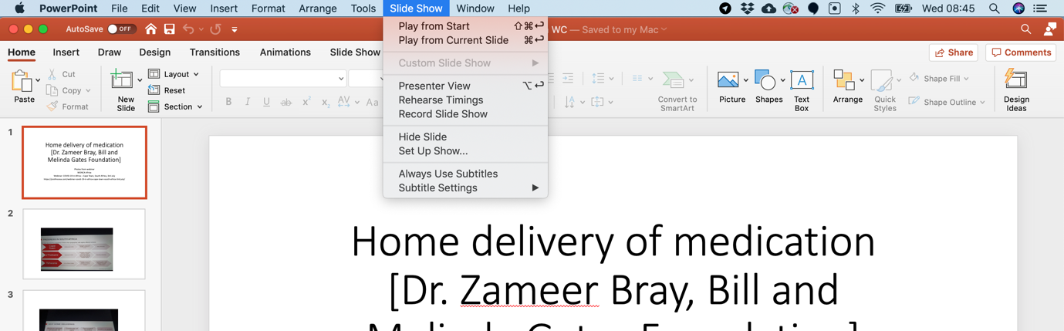

- Arrange a zoom with Shabir Moosa
Prepare your presentation (powerpoint or not). Email shabir@profmoosa.com to arrange a zoom meeting. He will then record either voice and/or video and prepare the video using slides (if you provide) or a picture (if you provide).
- Open Broadcaster Software.
Download OBS for free and make a screen recording. Send the recording via WeTransfer https://wetransfer.com/ to shabir@profmoosa.com.

Tips for good videos

Slides:
- If you choose slides, then have no more than 10 slides.
- Use images (if you can) and avoid more than 7 lines and 7 words per line
- Please add a slide with your contact details
Sound:
- Make sure there is no background noise (like traffic or other people).
- On the day of the webinar, you can do a test recording and listen to the sound to check for noise.
- Headsets generally give clearer audio than computer microphones.

Picture/framing:
- The camera should ideally be at eye level, the same height as your nose.
- Try looking into the camera lens while speaking for a greater connection with the audience as opposed looking at yourself on the screen.
- Aim to frame yourself in the center of the picture, like so:



Lightning/background:
- Make sure lighting is not too bright or too dim.
- Avoid having a window or bright lamp in the background, which will give you a “silhouette” appearance.
- Consider including a physical background that represents your organization (logo, flag, etc.). If you don’t have any physical materials available, just be conscious of what will appear in your background and make sure nothing distracting will appear on camera. In general, we don’t recommend virtual backgrounds as they can sometimes give you a “floating head” look.

Other tips:
- Wear professional attire. Be aware that people may screenshot you and post their photos on social media during/after the event.
- In a virtual format, it's more important than ever to keep language simple and clear, and avoid jargon to keep people's attention.

